CSCI-6461: PROJECT 1

Designed by – TEAM 5
Avish Kaushik
Harichandana Samudrala

Technology Used
Java OpenJDK 23

How To Run?
- Make sure you have updated version of JAVA installed
- Download the ZIP and extract loading.txt file and JAR file in the same place.
- Please use the following command in Terminal/CMD to run the JAR:

java -jar Simulator.jar

- After it run, you can provide the input file by clicking on IPL button which will open a dialog box. Select loading.txt file from that dialog box and click open.
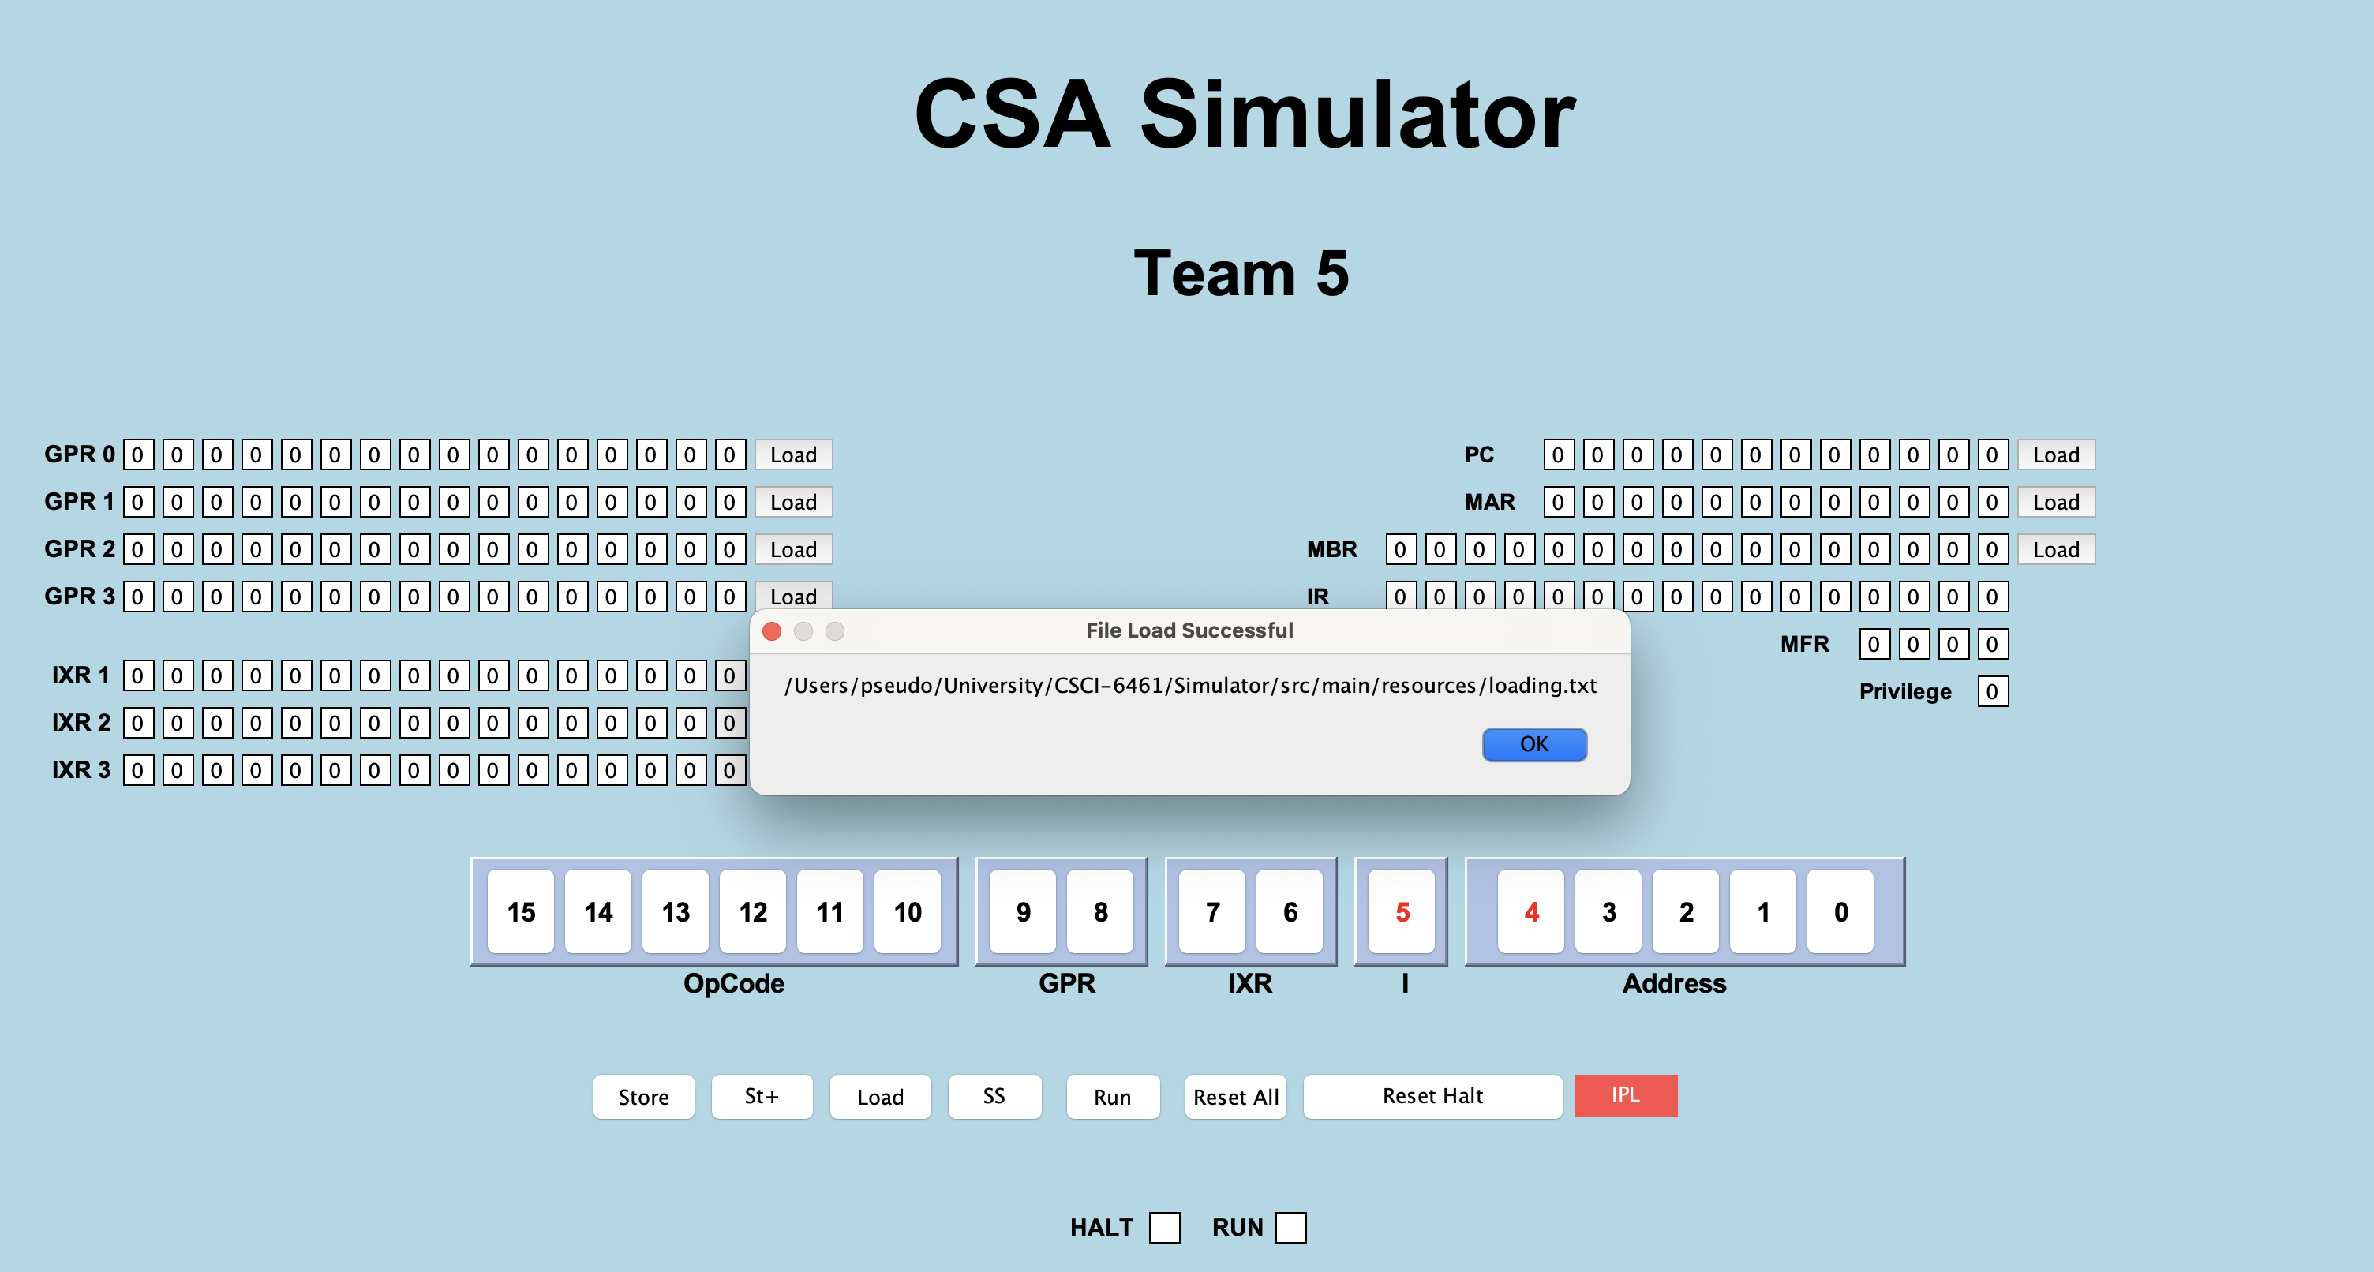

It will show that File Load Successful.

- You can click on Run button or SS button to run the simulator as per your needs.
